User Guide FOR SUMO SIMULATION APP

GROUP 2
Members: Quy Trang Duong | Thanh Hung Phan | Vo Minh Khoi Nguyen
| Duc Khang Nguyen | Quang Minh Khoa Le

- INTRODUCTION:
Welcome to the User Guide for Sumo Simulation App. This document is your simple starting point for understanding and using the this software. It is designed to provide you with the basic steps and a clear explanation of the main features of the program. With this application, you can quickly Zoom In and Zoom Out on the map, add new vehicles with custom colors and speeds, and directly control the color and timing (phrase) of traffic lights to see real-time effects on traffic flow. Additionally, the system allows you to perform a crucial Stress Test to push capacity limits and export a comprehensive statistics file for detailed performance analysis. Our goal is to make Sumo Simulation App using simple, direct, and successful for all your simulation needs.

- USER GUIDE
- Setup and connection
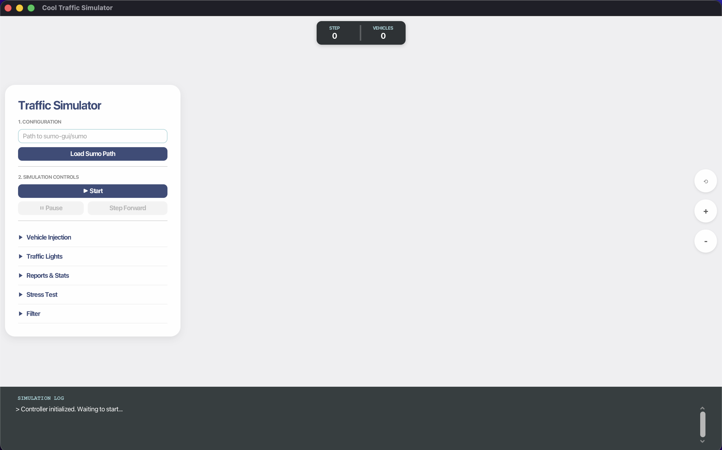
  - When you first open the app, you must enter your Sumo Path into the “Path to .sumocfg” text box, and then click “Load Sumo Path”.
  - If the Sumo Path is correct, the Simulation log section at the button of the app will display the text “Ready”.
  - Now, you can click the “Start” button to see the Map visualization and begin interacting with the app.

- Get Lane Ids, Zoom In/ Zoom Out, Rotate Map
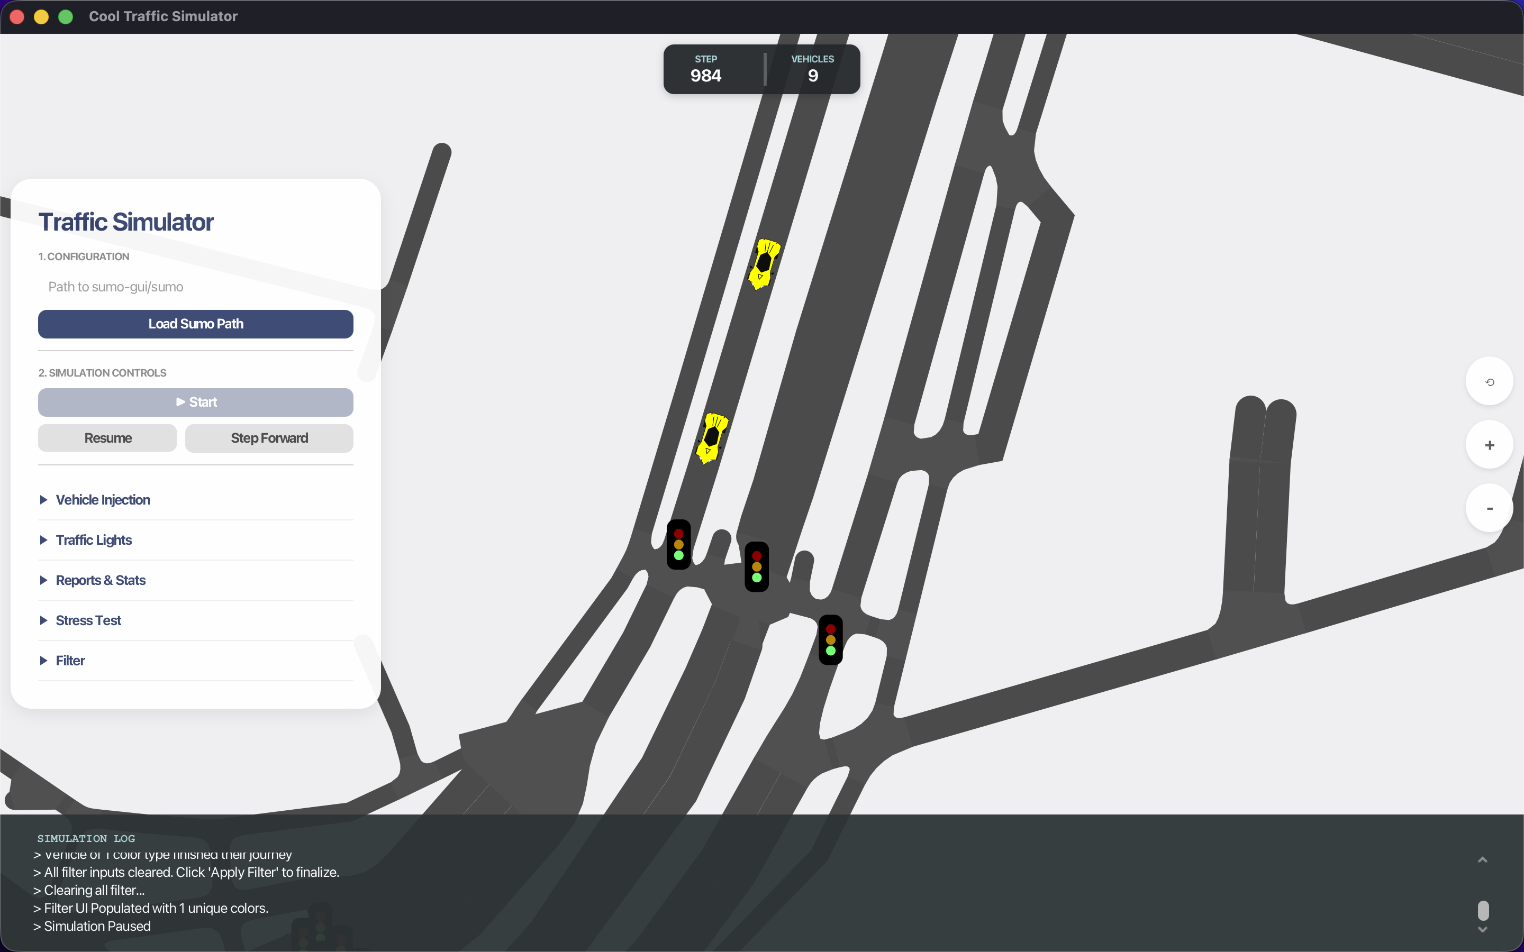

  - When the map is opened, you can click on every lane/road on the map to see its ID on the Simulation Log.
  - You can see car running on the road.
  - At the top of the app, you can track the real-time information regarding the number of steps and vehicles that the app has made.
  - On the right side of the map, you can see 4 little buttons:
+ 3D button: Not yet working.
+ Reset view button: Reset the map view to the original view.
+ Plus/Minus buttom: Zoom In/ Zoom Out Map
  - Move the Map: Click and hold the left mouse button on the map, then drag it around to explore different areas.
  - Zoom In/Out (Mouse): Roll your mouse wheel up to zoom in closer or down to zoom out for a wider view.
  - Zoom In/Out (Trackpad): Use a standard "pinch" gesture with two fingers on your trackpad to smoothly zoom in or out.
  - Rotate the Map: Click and hold the right mouse button while dragging sideways to spin the map view.
  - Rotate (Trackpad): Place two fingers on the trackpad and rotate them (like turning a dial) to change the map's orientation.
  - Reset View: If you get lost or the map is upside down, click the Reset View button to instantly return to the default position.
- Inject Vehicles
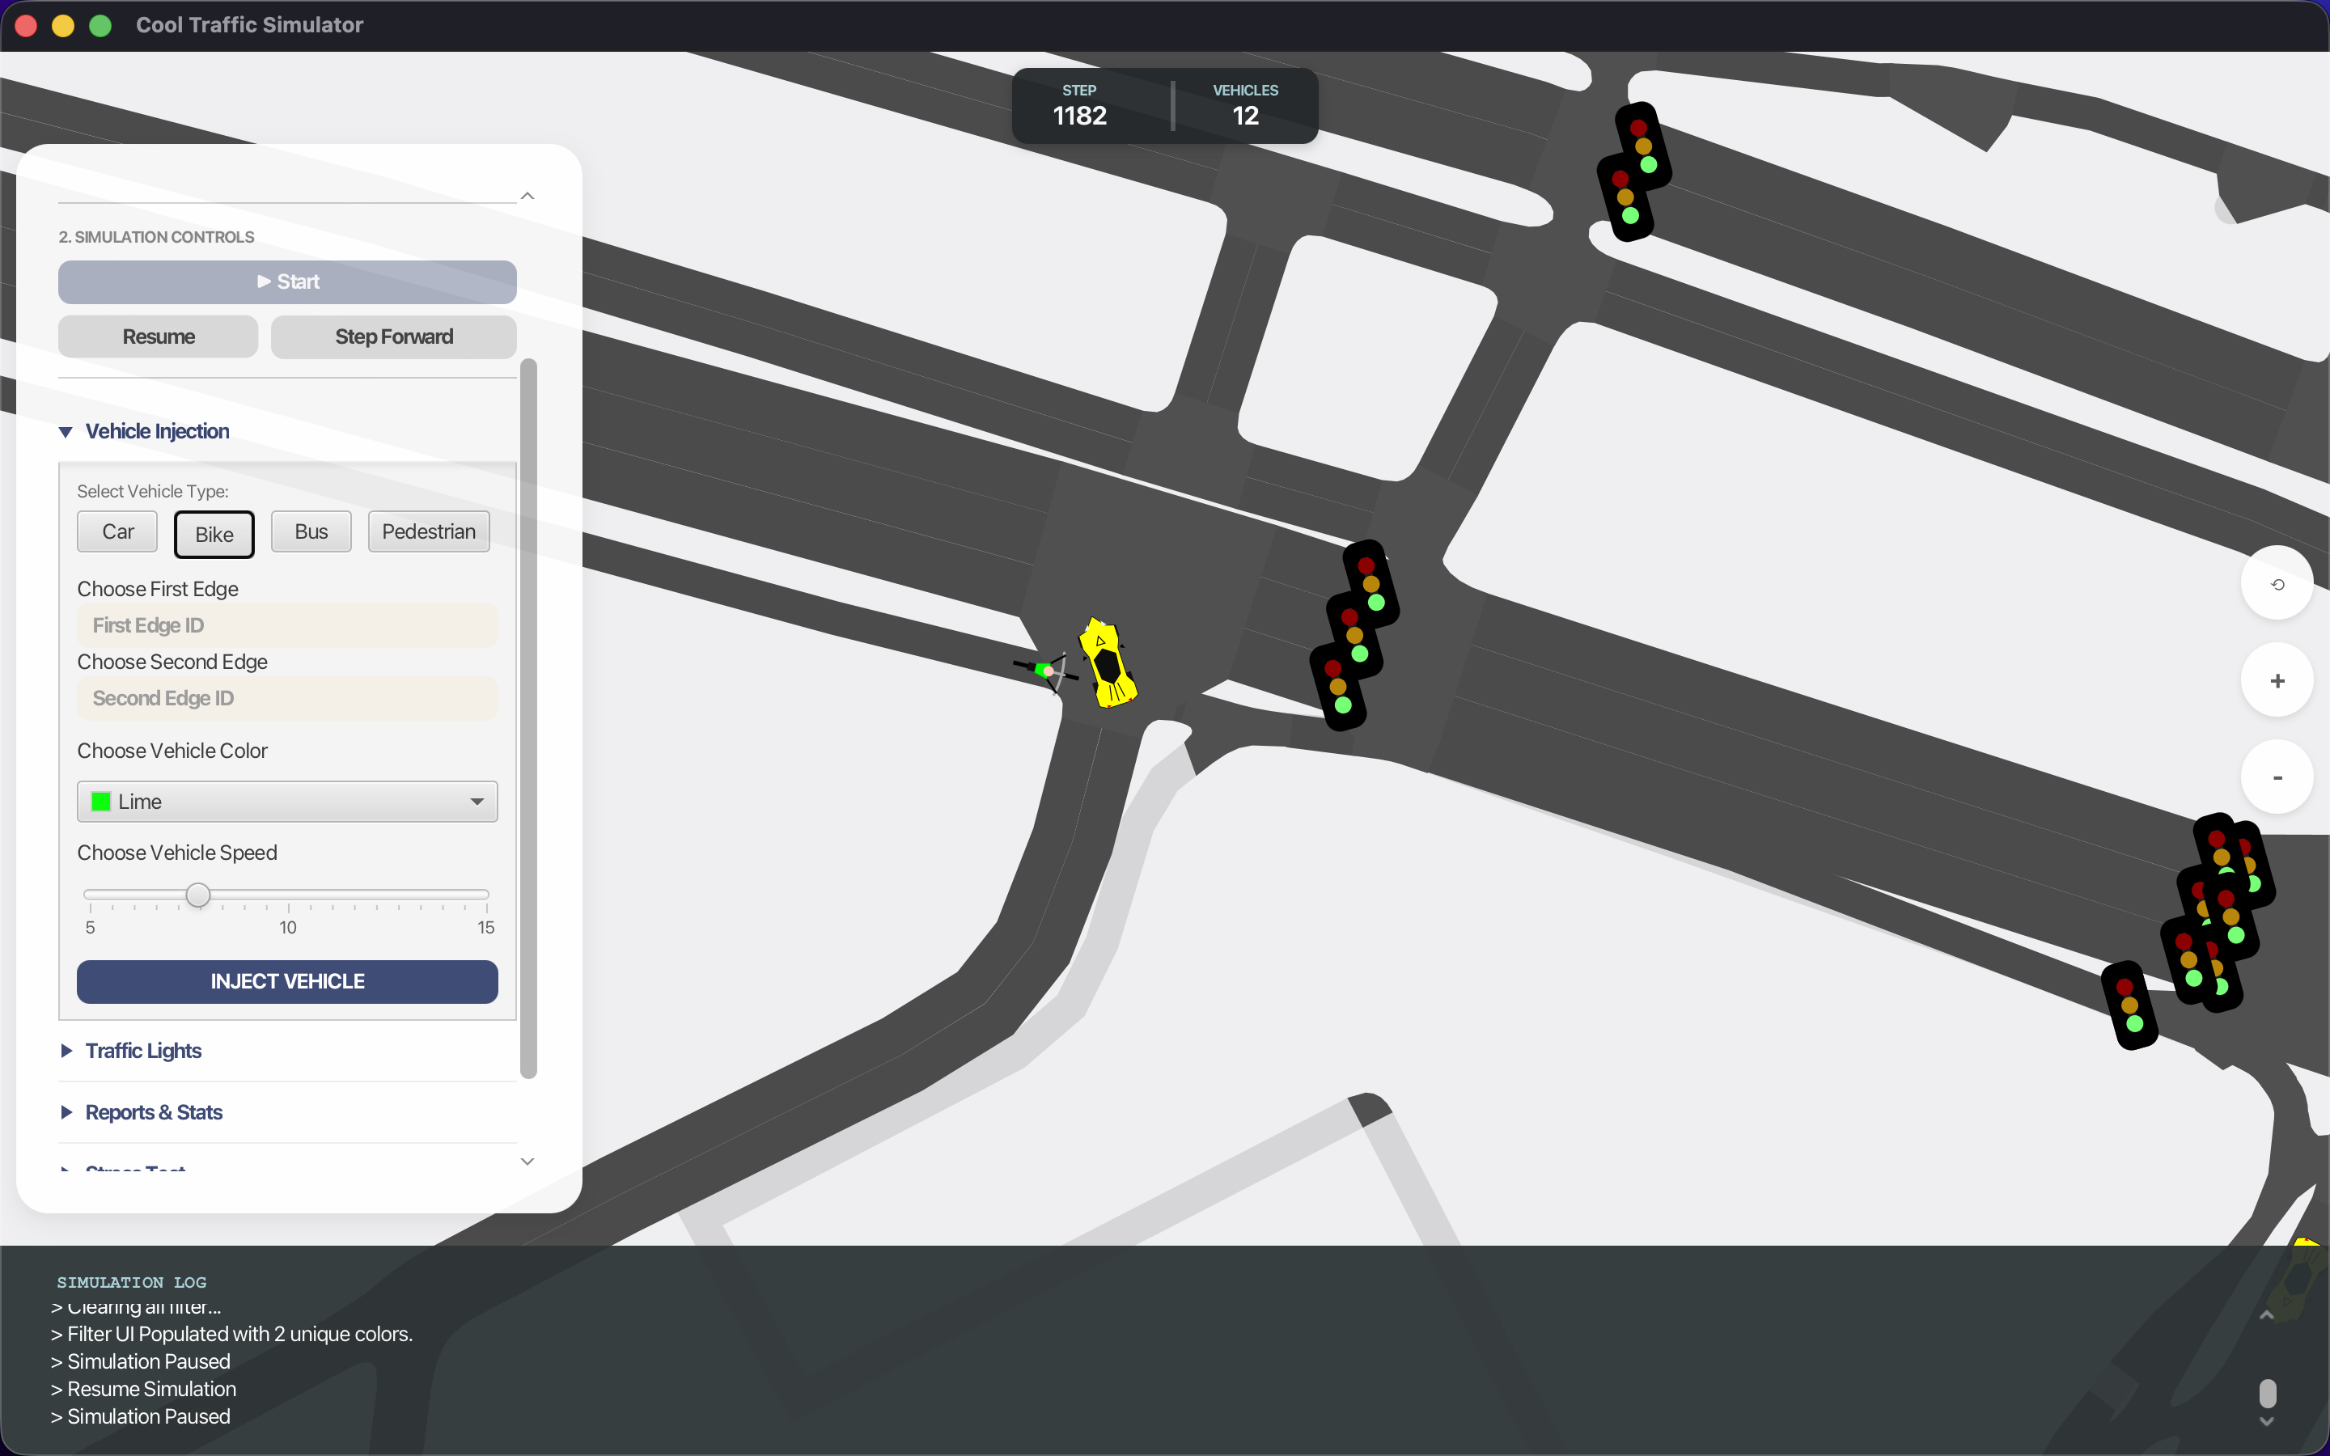

  - When you want to inject a vehicle, click on "Vehicle Injection"; a drop-down box will appear. The default vehicle is “Car”, but you can also change it to Bicycle, Bus, or Pedestrian.
  - After choosing vehicle types, move the mouse to the lane on the map and click on it to choose the First Edge and Second Edge sequentially to create the route for the vehicles. You can only choose the lane that allows a car or a bicycle, depending on your type choice.
  - If you want to choose different First and End Edges, you must choose both of these two Edges again, and sequentially.
  - You can choose the color for this Car and use the Slide bar to choose the speed. If you do not modify the color and speed, the default values are white and 10m/s.
  - Finally, click the “Inject Vehicle” button and you will see your car on the map.

- Traffic light control
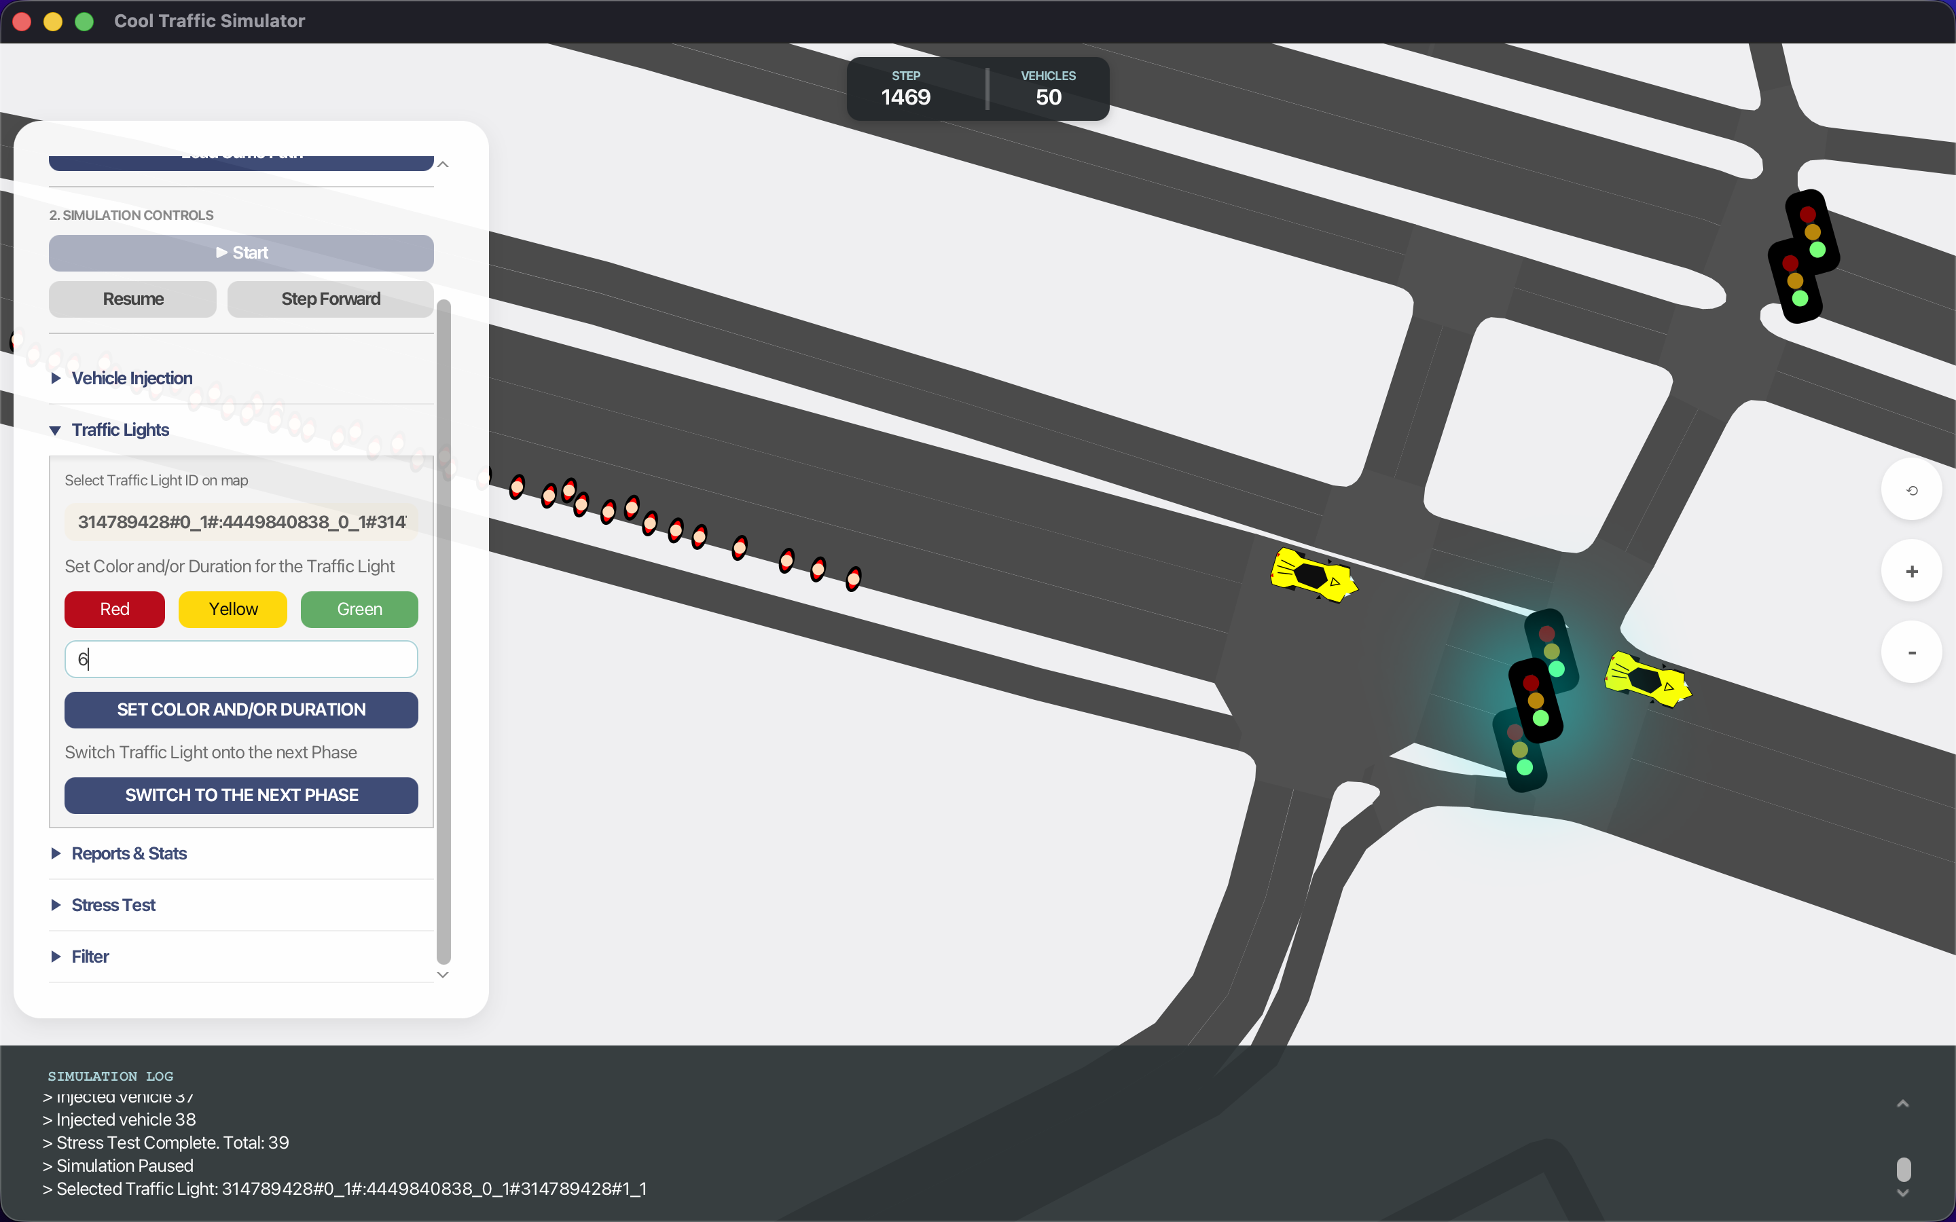

  - You can interact with the traffic light by hovering on the corresponding traffic light, when you click on it, it will log onto the Logger the id of the corresponding traffic light.
  - When the traffic light panel is opened, to use the functions inside that panel, you need to write text into the "Select Traffic Light id on map" by keep the panel opened and click on the traffic light you want to control. Make sure that the id of your desired traffic light put in the text field.
  - When the traffic light is closed, your clicking the traffic light will not write anything into the text field.
  - To switch to the next Phase, you choose the traffic light and then click the "Switch to the Next Phase" button on the panel, the whole traffic light system for that junction will change accordingly to the next phase.
  - You can change both or one of these 2 choices "Set Color" and "Set Duration". For the Duration, you should input a non-negative double, otherwise, the logger will not allow you to perform your action. For the color choosing, you can choose at most one color at a time, click the color box again to deselect (because you have an option to not setting the color).
  - If you want to set duration only, just leave the color not chosen, and click the "SET COLOR AND/OR DURATION", the duration of the current phase will be set to your desired amount of time.
  - If you want to set the color only, just leave the duration not inputted, and click the "SET COLOR AND/OR DURATION", the color of the whole junction will be changed to match the desired color of your desired traffic light.
  - If you want both, make sure you inputted both the color and duration, and click the "SET COLOR AND/OR DURATION", the color of the whole junction will be changed to match the desired color of your desired traffic light, and that will last for exactly that amount of time, but only temporarily (for only that phase and only once, the next time will return to the core logic in the configuration).

- Stress Test Control

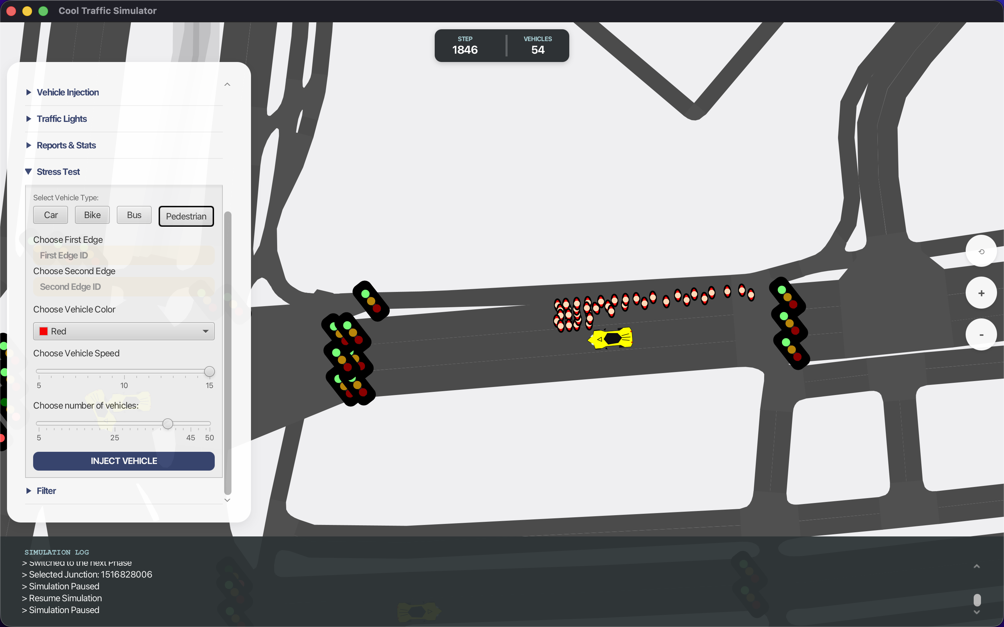

  - When you want to run a Stress Test, click the “Stress Test” button. A drop-down menu will appear. The default vehicle type is Car, but you can change it to Bicycle if desired.
  - To start the Stress Test, select the First Edge by hovering over and clicking on any edge on the map where you want to inject vehicles.
  - Next, select the Second Edge (the edge where the vehicles will exit) using the same method as selecting the First Edge.
  - You can also configure additional vehicle settings such as color, speed, and the number of vehicles to inject.
  - When you are finished, click “Inject Vehicle”, and the map will begin injecting vehicles according to your configuration.
  - You won’t be able to do an another stress test for 20 seconds because SUMO do not allow batch commands.

- Filter
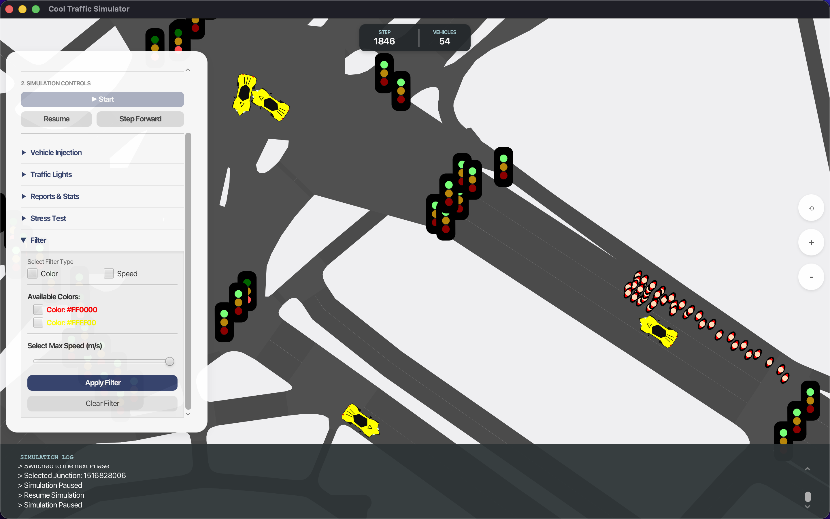
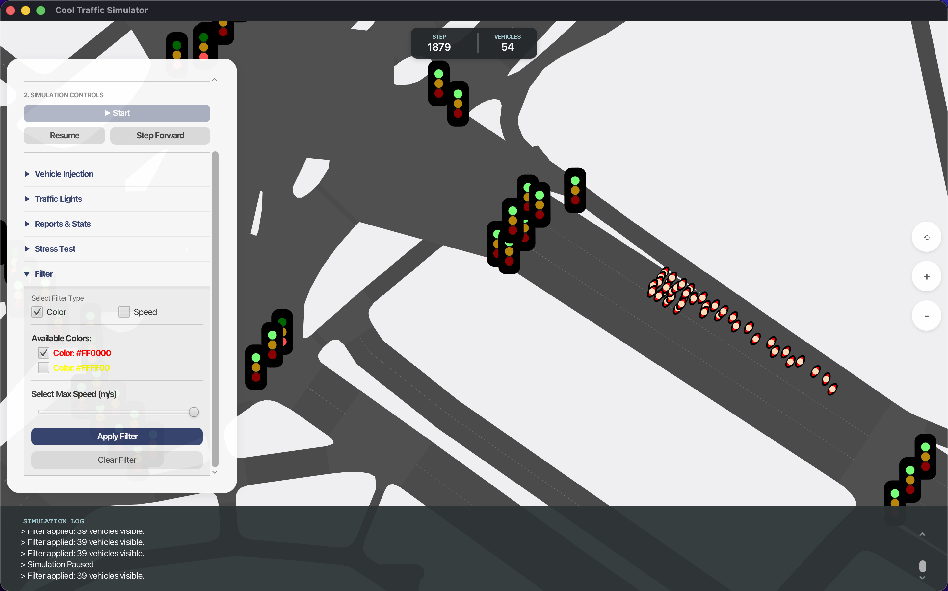
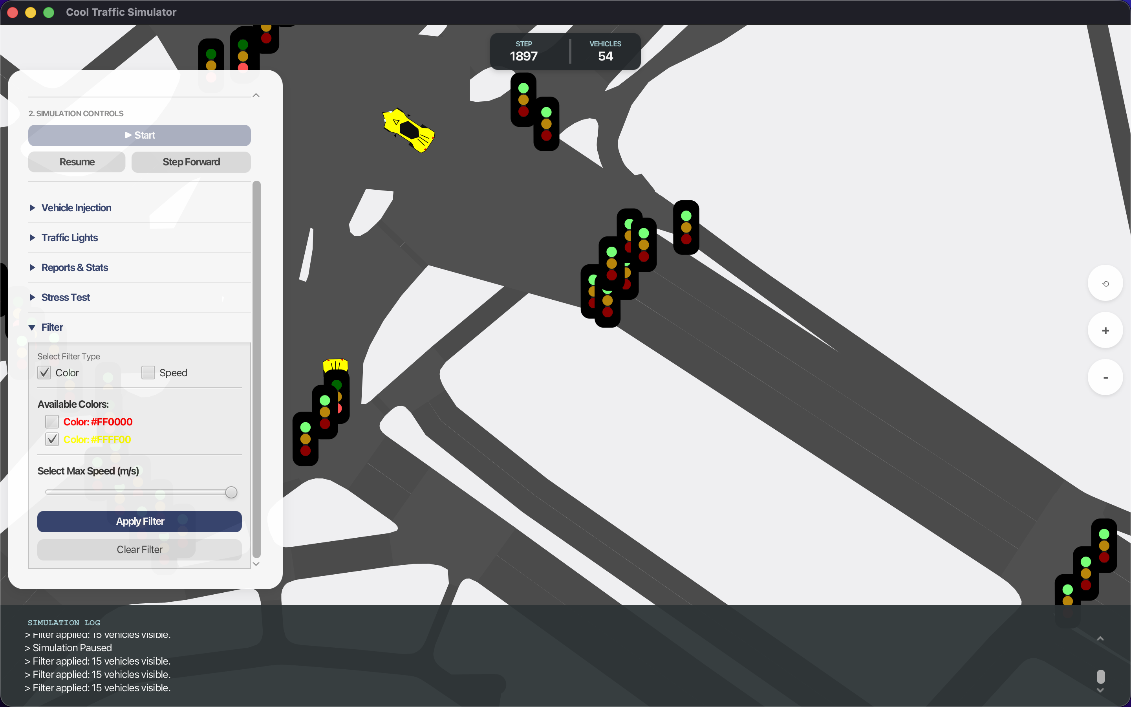
The Filter feature is designed to display only vehicles that meet specific criteria based on color, speed, or a combination of both.
To begin, the user must activate the filter by clicking the Filter Toggle, which enables the selection of filtering criteria. The user may choose to filter vehicles by color, speed, or both.
For the color filter, the user can select one or multiple colors corresponding to the colors currently used in the simulation. If no color is selected, no vehicles will be displayed.
For the speed filter, a slider is provided with values ranging from 0 to 30. Instead of selecting an exact speed, the user defines a maximum speed threshold. Vehicles with a speed less than or equal to the selected value will be shown.
Once the desired filtering logic is configured, the user must click Apply Filter to start the filtering process. After the filter is applied, any further adjustments to the filter settings are automatically applied in real time.
The filter remains active until one of the following actions occurs:
- The user clicks Clear Filter, or
- A new vehicle is added to the simulation through the Inject Vehicle or Stress Test feature, which resets the filter.

- Live charts
  - Open the Reports & Stats pane, there you will see a “View Live Charts” button, click it and the charts will pop up in a new window.
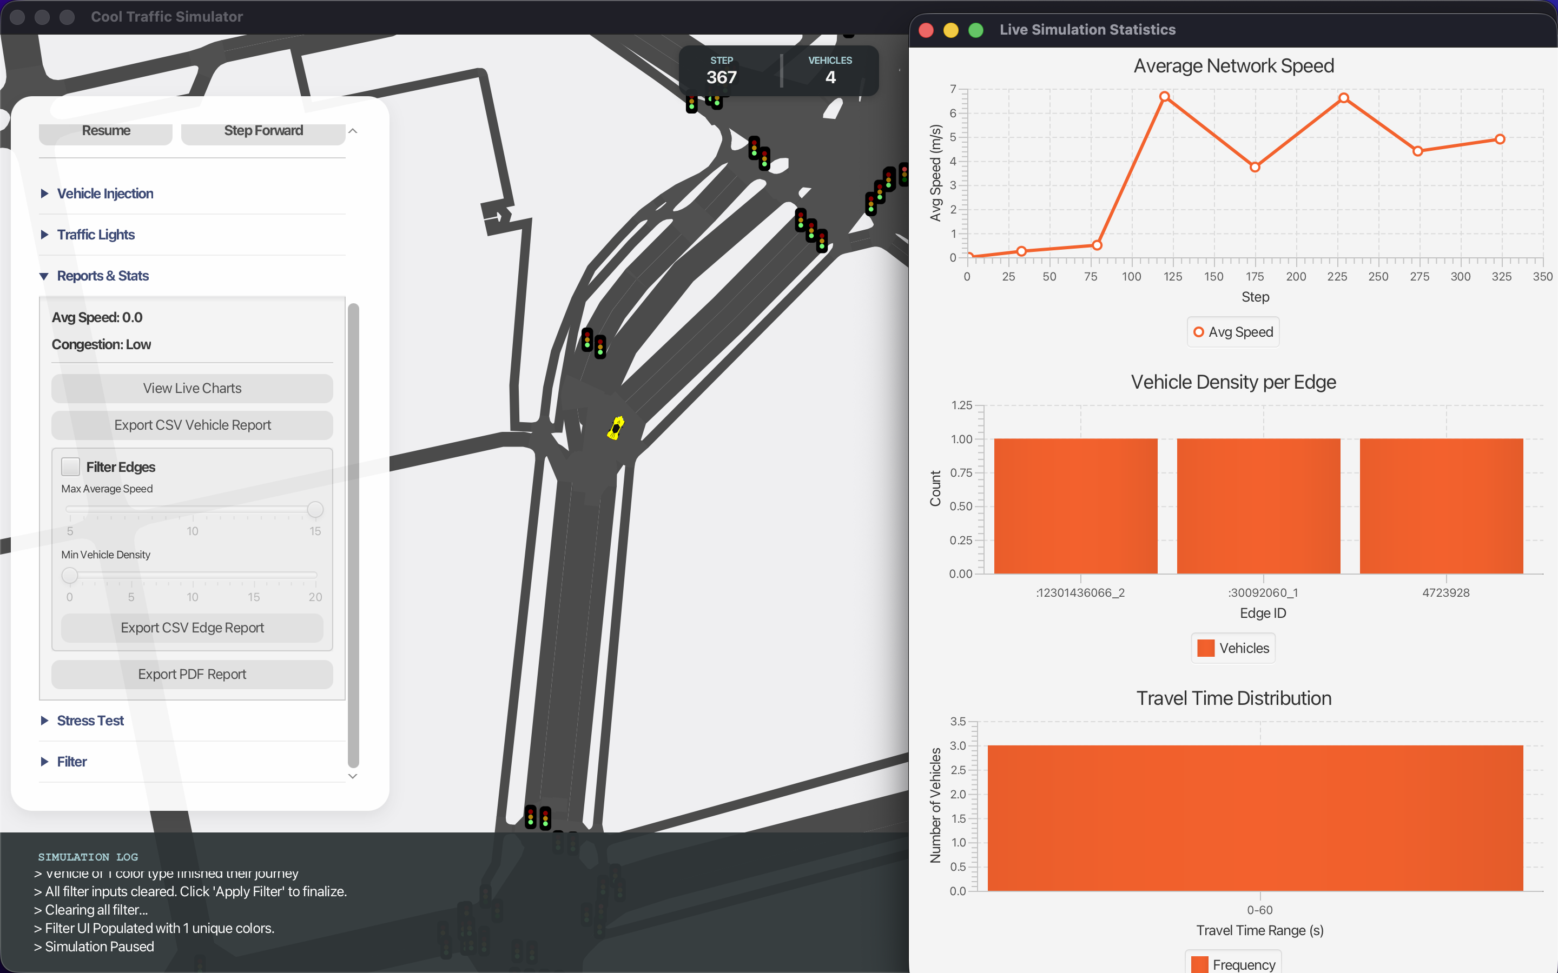

- Export PDF and CSV
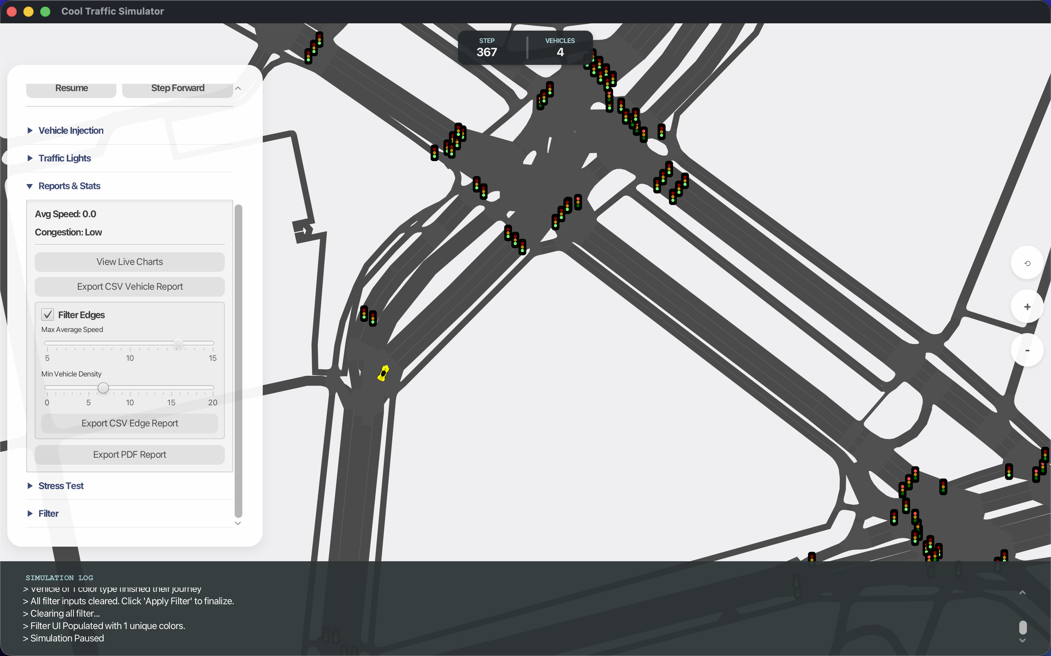
  - Open the Menu
  - Look at the control panel on the left side.
  - Click "Reports & Stats" to expand the options.
  - Click the "Export PDF Report" button at the bottom.
  - User can choose to Filter Edges
  - Use the slider to set the max speed and min vehicle density
  - Once everything is set, you can press “Export CSV Edge Report” or the “Export PDF Report” for a full report.
  - The PDFs and the CSV can be found in the “reports” folder of the project.

